**INFORMATICS AND COMPUTATIONAL SCIENCE**

**UNIVERSITY COLLEGE OF SCIENCE**,

**MOHANLAL SHUKHADIA UNIVERSITY, UDAIPUR**

**BACHELOR OF COMPUTER APPLICATION**

**( A Choice Based Credit System )**



**BCA-5th SEMESTER**

**2023 – 24**

**[BATCH-A]**

**MINOR PROJECT SYNOPSIS**

ON

**“ CAFEESA ”**

**Submitted To :- Submitted By :-**

**Mr. Jitesh Kumar Mr. Anand Dubey**

**Title:-“ CAFEESA ”**

**LOGO**



**Members in the project :- Anand Dubey & Balwant Kumar**

**Introduction:**

The Cafeesa Website project seeks to elevate the dining experience for patrons of Cafeesa by introducing a user-friendly table reservation feature. As a bustling cafe known for its exceptional coffee, delectable pastries, and inviting ambiance, Cafeesa recognizes the importance of providing customers with convenient and efficient ways to secure their dining arrangements. With the growing demand for online booking services in the hospitality industry, the implementation of a reservation system on the Cafeesa website aims to meet the evolving needs of customers while optimizing operational processes for the cafe.

This introduction will provide an overview of the project's objectives, key features, target audience, and anticipated outcomes, setting the stage for a detailed exploration of the reservation feature's functionality and benefits. By seamlessly integrating online reservation capabilities into the Cafeesa website, the project endeavors to enhance customer satisfaction, improve table utilization, streamline operations, and ultimately support the cafe's continued growth and success in the competitive food and beverage market.

**Objectives:**

Enhance Customer Experience: Provide customers with a convenient and user-friendly platform to reserve tables at Cafeesa, minimizing wait times and ensuring a seamless dining experience.

Optimize Operational Efficiency: Streamline table management processes for cafe staff, reducing manual workload and improving overall efficiency in seating allocation and service.

Increase Revenue Potential: Maximize table utilization during peak hours by implementing a real-time reservation system, thereby increasing revenue generation opportunities for the cafe.

Foster Customer Loyalty: Enhance customer satisfaction and loyalty by offering a hassle-free reservation experience, encouraging repeat visits and positive word-of-mouth referrals.

Support Business Growth: Contribute to the long-term success and growth of Cafeesa by aligning with modern consumer preferences and industry trends in online booking services.

**Key Features:**

User-Friendly Reservation Form: Intuitive interface allowing customers to easily specify date, time, party size, and any special requests.

Real-Time Availability Updates: Instantaneous updates on table availability to prevent overbooking and ensure accurate scheduling.

Confirmation and Notifications: Automated email or SMS confirmations and reminders for customers to minimize no-shows and facilitate smooth operations.

Modification and Cancellation Options: Flexibility for customers to modify or cancel reservations online, enabling efficient management of table allocations.

Integration with POS System: Seamless integration with the cafe's point-of-sale system for improved coordination between front-of-house and back-of-house operations.

**Target Audience:**

Local Residents:Regular patrons seeking a convenient way to secure their preferred dining arrangements at Cafeesa.

Tourists:Visitors to the area looking for a memorable dining experience and the opportunity to explore local cafes.

Professionals:Business professionals seeking a comfortable environment for meetings or work sessions over coffee and snacks.

Special Occasions:Individuals planning celebrations or gatherings at Cafeesa, such as birthdays, anniversaries, or group outings.

Convenience-Seekers:Customers who prioritize convenience and prefer to plan their dining experiences in advance, avoiding long wait times or disappointment upon arrival.

**Anticipated Outcomes:**

Improved Customer Satisfaction: Enhanced dining experience for customers with a seamless and hassle-free reservation process.

Increased Operational Efficiency: Streamlined table management processes leading to improved staff productivity and service quality.

Enhanced Revenue Generation: Maximized table utilization resulting in increased sales and revenue potential during peak hours.

Strengthened Customer Loyalty: Positive experiences with the reservation system fostering repeat visits and positive word-of-mouth referrals.

Long-Term Business Growth: Alignment with modern consumer preferences and industry trends contributing to the continued success and growth of Cafeesa in the competitive food and beverage market.

**Conclusion:**

The implementation of a table reservation feature on the Cafeesa website represents a strategic initiative to enhance the dining experience for customers while optimizing operational efficiency for the cafe. By providing a user-friendly booking platform, real-time availability updates, and seamless integration with the POS system, the feature aims to streamline the reservation process and maximize customer satisfaction. As a result, Cafeesa can expect to see increased patronage, improved table turnover rates, and enhanced customer loyalty, contributing to the cafe's overall success and growth trajectory.

**Technical Specifications (Hardware and Software):**

**Hardware:**

|  |  |
| --- | --- |
| Specification | System1 |
| Processor | Intel(R) core(TM) i3-10110U CPU @2.10GHz 2.59GHz |
| Operating System | Window 11 Home Single Language |
| RAM | 8GB |
| ROM | 256GB SSD 1TB HDD |
| Graphic | Integrated 4gb Graphics card |
| Brand | Lenovo |

**Software:**

**Vs code -** Visual Studio Code is a streamlined code editor with support for development operations like debugging, task running, and version control. It aims to provide just the tools a developer needs for a quick code-build-debug cycle and leaves more complex workflows to fuller featured IDEs, such as Visual Studio IDE.

**Chrome -** Google Chrome is a popular, free web browser. With Chrome browser, you can: Get personalized search results that appear instantly as you enter text. Synchronize bookmarks and settings across all your devices. Use Google Workspace products, such as Google Docs, Sheets, Slides, and more. Technology

**Frontend:**HTML,CSS

**Backend:** JavaScript, php

**Database:**mysql

**Database Design:**

**Admin Table:-**

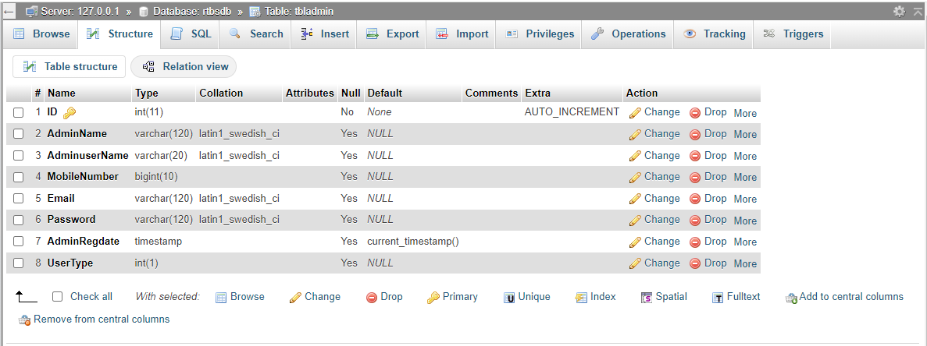

**Booking Table:-**

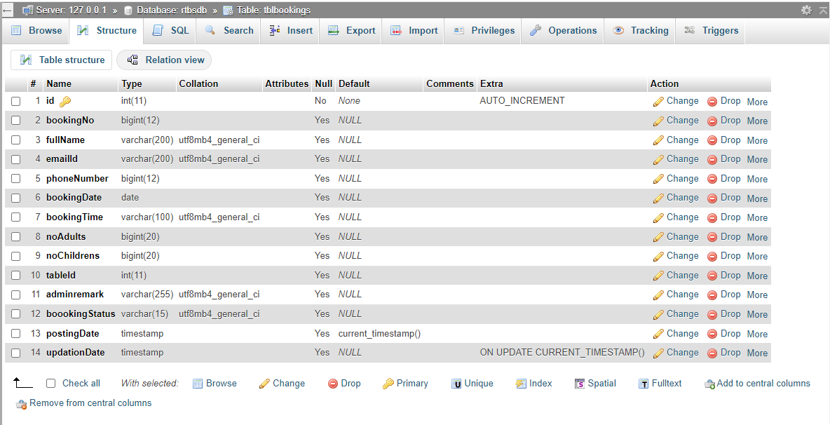

**Seats Table:-**

